INCLUDEPICTURE "http://www.blct.org/images/logo-with-text2.jpg" \* MERGEFORMATINET

Welcome to the Barrington Land Conservation Trust!

The BLCT Board of Directors and your fellow volunteers are excited to have you with us. As a volunteer, you will help preserve and protect the natural resources of the Town of Barrington, Rhode Island, and adjacent areas including water resources, streams, ponds, marshlands, woodlands, and other scenic and natural sites, as well as the plant and animal life therein.

The handbook provides information that will help explain the history, mission, and projects of the Barrington Land Conservation Trust, as well as information to help you get started as a volunteer and to use as a reference as your volunteer experience develops.

Please feel free to bring any questions or concerns to the staff. We are pleased to have your time, talent, and energy on our team and hope that you will have a positive and meaningful volunteer experience!

Thank you for joining us!

Barrington Land Conservation Trust

Who We Are
The Barrington Land Conservation Trust, Inc. is a private, non-profit, tax-exempt organization. Its purpose is to preserve the remaining natural resources of the Town of Barrington, Rhode Island, and adjacent areas including water resources, streams, ponds, marshlands, woodlands, and other scenic and natural sites, as well as the plant and animal life therein. We achieve our objective through land acquisition, educational programs and advocacy on the state and local level. The Trust now owns over 120 acres of land in the Town, including Johannis Farm Wildlife Preserve, PIC-WIL Nature Preserve and other smaller environmentally sensitive parcels. We hold our properties for the benefit of all the citizens of Barrington. We cooperate with other nearby land trusts, the Audubon Society and The Nature Conservancy.

Why We Were Organized
We face ongoing pressure to develop all remaining land in town. To continue our efforts to retain as much of Barrington's natural vitality as possible, we acquire by gift, conservation easement or purchase (when funds are available) tracts of presently undeveloped land. We manage this land and concern ourselves with the land's natural features and with the specific desires of the owners.
How We Help the Town and Residents
Donations or easements to us supplement the Town's open space programs. We work closely with the town Conservation Commission and town officials. However, as a private organization outside the realm of politics, we can move quickly and with great flexibility. We also acquire parcels of land that may be too small for the Town's consideration. Every piece of Barrington land set aside for conservation adds to the value of the entire community, as it helps to preserve the beauty and natural health of the town.
Your property will remain valuable as long as Barrington is a desirable place in which to live. The educational and advocacy programs of the Trust have assisted both the Town government and residents in minimizing damaging development and managing properly the Town's private and public open space. These efforts have a significant positive effect on the overall quality of life in our community.

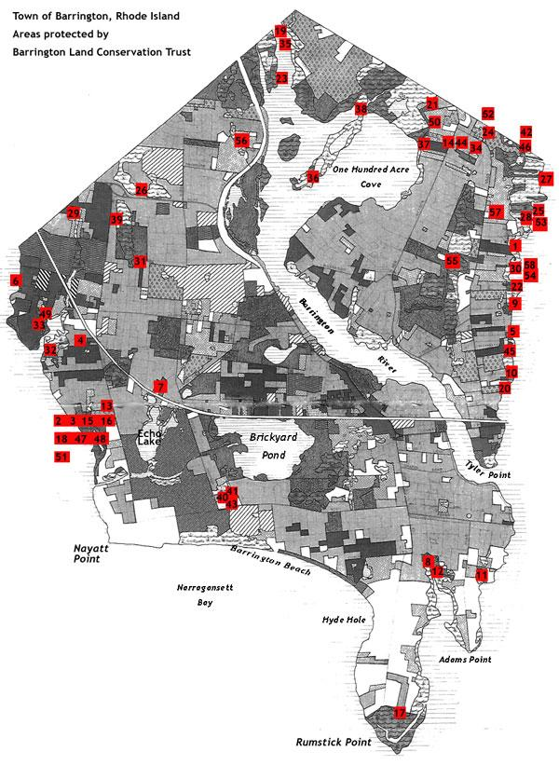

Volunteer Rights and Responsibilities

As a volunteer you have the right to:
- Clear, appropriate, fulfilling volunteer assignment
- Orientation, training, and on-going support
- Informed involvement with agency
- Time put to best use
- Open line of communication with project supervisor
- Safe, healthy working conditions
- Respect and recognition of service

As a volunteer you have a responsibility to:
- Be honest about goals, skills, limitations and motivations
- Fulfill your commitment
- Maintain confidentiality
- Cooperate with staff
- Be flexible and open-minded
- Stay informed
- Ask for help - it’s OK!

Volunteer Policies

Record keeping procedures - Due to the independent nature of many of our volunteer projects, we are counting on you to help us keep track of your hours. Tracking volunteer hours and contributions helps us show the community what great work you are doing, and helps us bring in more funds that enable us to continue our conservation efforts.

Included in your handbook is a Volunteer Time Sheet. On this sheet, you are asked to write down the date of your service, the project and location you worked on, a brief description of your activities, and the number of hours worked.

On a monthly basis or as the timesheets are filled, they can be left with your supervisor, mailed or emailed to Volunteer Coordinator Jennifer Styles at:
The Volunteer Center of RI
55 Bradford Street, Ste 302
Providence, RI 02903

Email:
jstyles@vcri.org

For questions about timesheets call Jennifer at 401-421-6547

Evaluation – In order to continue adapting and improving our volunteer program, volunteers will receive annual performance reviews. The evaluations allow for a volunteer and supervisor to suggest changes and seek suggestions. The evaluation is discussion period, and both supervisor and volunteer should establish an open line of communication.

Volunteers Under the Age of 18 – All volunteers under the age of 18 must have a form signed by their parent or guardian permitting them to volunteer.

Relations with the Public – When dealing with the public, especially site visitors and neighbors, remember that you are a representative of the Barrington Land Conservation Trust and have an important role to play in enhancing the public’s perception of our conservation efforts. You have the opportunity to encourage responsible visitor behavior and reinforce public support of natural open space preservation.

It is not your responsibility to resolve boundary or other property conflicts with neighbors. If a neighbor or visitor confronts you with an issue, take the person’s information and tell them that you will have your supervisor contact them to address the situation. Do not approach anyone you feel may be threatening or dangerous. Move to a safe distance and call the police or your supervisor.

Safety – Your safety is of utmost concern to us. While out on volunteer assignment, if you encounter or witness and urgent problems or threatening situations, (fire, open firearms, hunting/trapping, unknown hazardous material or pollutant) immediately remove yourself to a safe distance and contact the authorities and your supervisor.

Confidentiality - Volunteers assigned to assist with data management may be working with records containing personal or financial information and are expected to respect the confidentiality of that information. Additionally, volunteers may learn information that has not been released to the public or is not intended for the public. Volunteers are expected to maintain the confidentiality of that information.

Resigning as a Volunteer – If find that you are unable to complete your volunteer service, it is your responsibility to let your supervisor know as soon as possible, so that the work can be reassigned.

Position: Conservation Easement Monitor

Purpose: To monitor, protect, and enhance conservation easements (protected areas of land) owned and/or managed by the Barrington Land Conservation Trust in order to help us preserve Barrington’s unique scenic, historic and natural open spaces!

Responsibilities:
- Monitoring, recording, and keeping paperwork up to date on the condition of assigned site/property, reporting on construction, litter/waste, and boundary issues.

- Monitoring vegetation/plant life, particularly keeping an eye on invasive plant species

- Report suggestions of areas of trail maintenance and clean-up projects that need attention

Qualifications:
- The initiative and flexibility to work independently
- Knowledge of the natural environment is helpful but not necessary
- Have an interest in protecting and preserving the natural environment of our community

Time commitment: Easement site reports are completed once a year. You will have the option of participating in additional maintenance and clean-up projects on the sites that may occur as needed.

Training: A group or individual orientation will be provided to cover position expectations, goals, and reporting procedures. Additional on-the-job training may be offered throughout your service.

Supervision: Due to the independent nature of the projects, supervision will mainly be off site once the volunteer is comfortable with the project, but the volunteer manager and staff will be available via phone and email to answer questions.

Volunteer Contract
This contract outlines our commitment to you and expectations for the services you will be performing. We appreciate your services and want to do the very best in making your volunteer experience here productive and rewarding.

Agency:
We _______________________________________ (agency), agree to accept the services of _______________________________________ (volunteer name) beginning ______________ (date), and we commit to the following:

- To provide a clearly defined volunteer position description with appropriate supervision and direction whether on-site or on-call
- To provide adequate training and job assessment feedback and to be receptive to volunteer feedback.
- To respect the skills, knowledge, and individual needs of the volunteer

Volunteer:
I _________________________________________ agree to serve as a volunteer and commit to the following:

- To perform volunteer duties as outlined in my volunteer position description to the best of my ability
- To adhere to agency rules, policies, and procedure, including record keeping requirements and confidentiality of agency information
- To meet time and duty commitments or to provide adequate notice, so that alternate arrangements can be made

Volunteer: Agency Representative:

_________________________________ ___________________________________
(Signature) (Signature)

_________________________________ ____________________________________
(Date) (Date)

Volunteer Time Sheet

Volunteer name: ______________________________________

Date | Project/Location | Tasks Completed | Total Hours

Volunteer Time Sheet

Volunteer name: ______________________________________

Date | Project/Location | Tasks Completed | Total Hours
Resources and links of interest:

Land and Water Conservation Partnership Websites
- Rhode Island Land Trust Council - http://www.rilandtrust.org/
- Barrington Land Conservation Trust - http://www.blct.org/
- The Westerly Land Trust - http://www.westerlylandtrust.org/
- Rhode Island Rivers Council - http://www.ririvers.org/
- Wood-Pawcatuck Watershed Association – http://www.wpwa.org
- The Woonasquatucket River Watershed Council - http://www.woonasquatucket.org/
- The Volunteer Center of Rhode Island – http://www.vcri.org

Environmental and Educational Resources:
- RI Department of Environmental Management - http://www.dem.ri.gov/index.htm
- URI Watershed Watch – Researched based education and training programs helping Rhode Islanders protect their water resources and health - http://www.uri.edu/ce/wq/
- The Nature Conservancy, RI Chapter – state and nationwide conservation information - http://www.nature.org/wherewework/northamerica/states/rhodeisland/
- Invasive Plant Atlas of New England (IPANE) – Information on identification and management of invasive plant species - http://invasives.eeb.uconn.edu/ipane/
- Greenways Alliance of Rhode Island – Information about RI’s bike paths, trails, and greenspaces and events - http://www.rigreenways.org/
- RI Natural History Survey – Information from a consortium of organizations and individuals about Rhode Island’s biology, geology, and ecosystems. http://www.uri.edu/ce/rinhs/index.htm

